Logging in and Managing User Settings
Objective
After completing this lesson, you will be able to configure settings within SmartRecruiters to optimize user experience and workflow efficiency.
Personal Settings Configuration
As a new or existing user of SmartRecruiters, understanding how to log in and configure your personal settings is crucial for an efficient and personalized recruiting experience.
Creating a Password
When you're initially added as a user to SmartRecruiters, you will receive an email invitation. This email contains specific instructions for creating your password for the first time.
After setting up your password, you might be required to verify your email address. In such cases, SmartRecruiters will send a verification email to the address you provided. Simply click on the link provided in the verification email to be directed into SmartRecruiters.
Forgotten Password
If you've forgotten your password and you're not using Single Sign-On (SSO), click the Forgot Password link located below the email field. This will trigger an email to your email address with instructions to reset your password.
Single Sign-On (SSO)
If your organization uses Single Sign-On (SSO), the login process may be slightly different:
- You might not be prompted to enter a password.
- Depending on your system's configuration, you may only need to enter your email address, which will then be recognized by your SSO provider, granting you access to SmartRecruiters.
View and Adjust Your Settings
Once you're logged into SmartRecruiters, you can access your user settings by following these steps:
Steps
- Navigate to Settings.
- The Settings page is divided into several sections, including My account and My purchases. Depending on your user role (such as an admin or custom role), you may also see additional ​​company-wide settings.
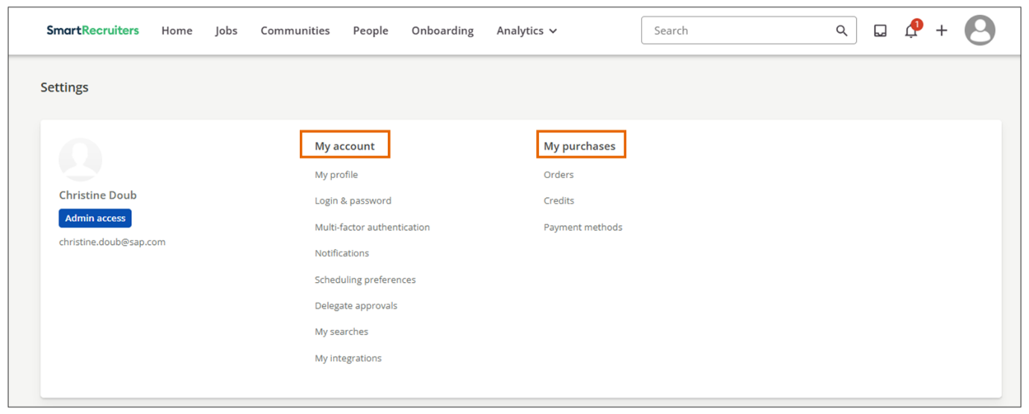
- In the My purchases section, you can view details about your current job board orders, available credits, and payment methods. This section is particularly useful if you've purchased job postings or assessments from the SmartRecruiters Marketplace.
- The My account section allows you to manage your personal information and preferences.
My profile: Here, you can enter or update your personal details, such as your name, ​​​position​, and contact information. You can also do the following:
  - Choose whether to display your name on job ads that you post.
  - Select your preferred language and time zone. Setting the correct time zone is crucial for scheduling interviews and ensuring the timely delivery of emails.
Note
If your organization has SmartRecruiters integrated with a user synchronization setup (for example, via an HRIS or identity provider like Okta/Azure AD using SCIM/SAML), the lifecycle of company user accounts is controlled by that sync. In those environments, you might not see that button.
In the Login & password section, you can change your login email and password.
Note
This section is not available if you are using Single Sign-On (SSO).
Additional Profile Settings
Notifications Section
The Notifications page allows you to customize the types of emails and alerts you receive from SmartRecruiters. You can choose to receive notifications based on your role on the hiring team (e.g., hiring manager, coordinator, interviewer).
​​​There are six categories of emails you can configure, so it's essential to review each section and select the notifications that are most relevant to your role and responsibilities.
Note
An administrator can update the notification settings under Global Notification settings. If the notification is enabled at the global settings level, the user can adjust it (switch it on or off) based on individual needs.
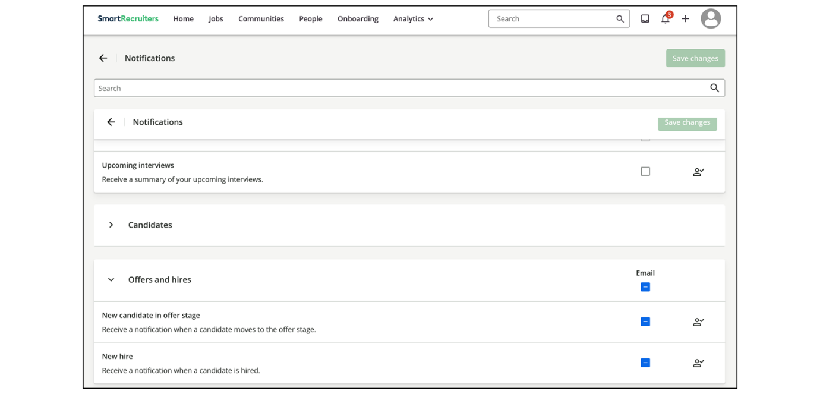
Scheduling Preferences
In this section, you can set up your availability and preferred timeslots for interviews. You can also set an Out of office and other interview preferences like the number of interviews per day or buffer time, for example, or the advance time you'd like to allow when auto-scheduling interviews.
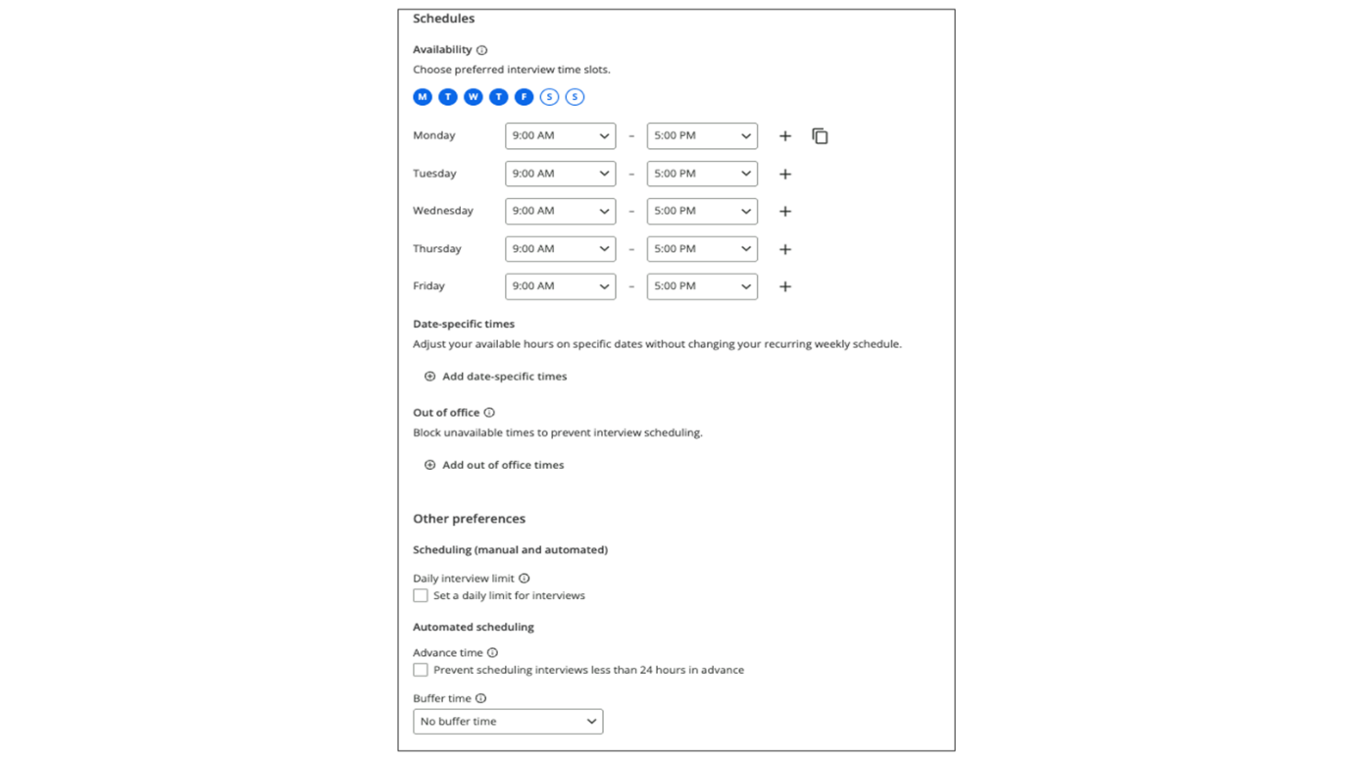
Delegate Approvals Section
If you plan to be away from work for a period, you can use the Delegate Approvals page to assign another user to handle job or offer approvals on your behalf.
To delegate approvals:
- You can provide the start and end dates of your absence.
- You can select the user who will receive the approvals.
- The designated user will then receive any approvals sent to you during the specified period.
- You can end the delegation early if needed.
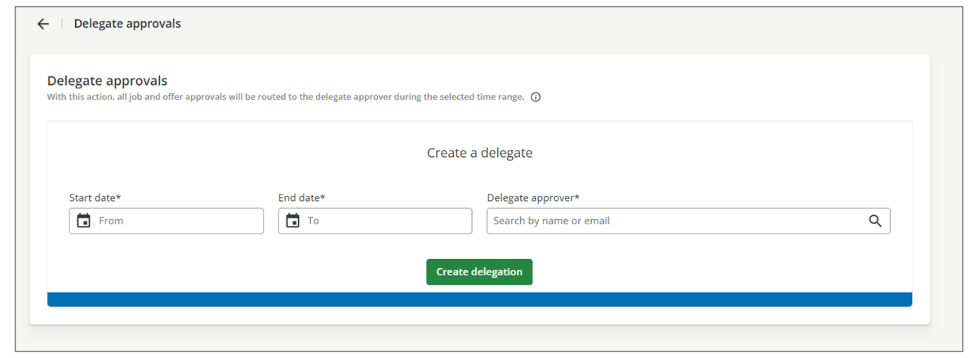
When approvals are delegated, only the designated user receives the job or offer approval request. The original approver (who created the approval) will not receive an email or a notification in the Home Page Approvals widget at the same time.
When the original approver returns at the end of the delegation period, or cancels the delegation early, any approvals that are still pending remain assigned to the designated user. They are not automatically redirected back to the person who created the approval.
It functions the same way for items that are awaiting approval from the person who created the approval (the original approver). These approvals are not transferred to the designated user and must be approved or rejected by the original approver before a delegation is set up.
My Searches Section
The My Searches page allows you to view and manage your saved searches. Clicking on a saved search will take you to the People page, where the search criteria filters will be pre-populated, allowing you to review applicants quickly.
Next to each saved search, you can see the number of new applicants, add the search to your home page, edit the search name, or delete the search. The Search History tab displays a list of when your searches were last run.
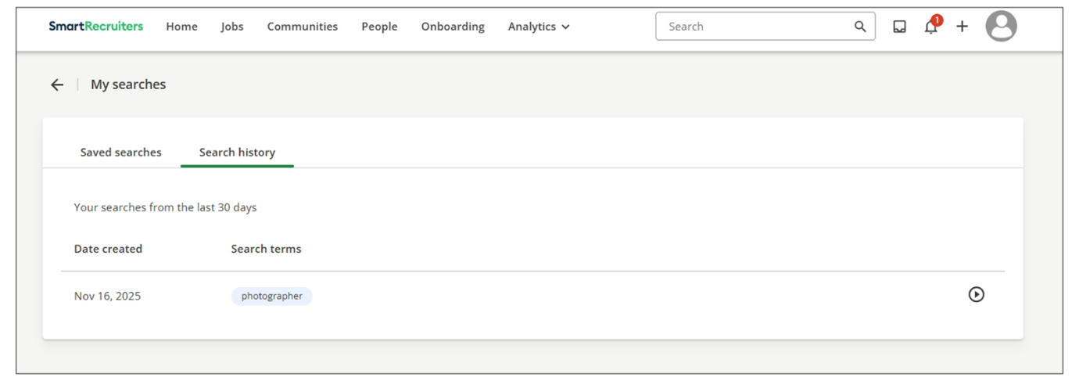
My Integrations Section
The My Integrations page displays available integrations and their current status. The status icon indicates whether an integration is currently enabled.
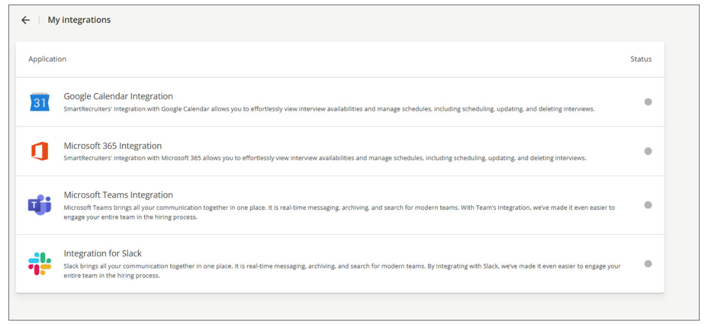
Watch the video below for more information about login and user settings.
This video is for demonstration purposes. Any references made in this video to previous or later videos in this course (including titles, numbers, links, or sequence) may differ from the current course structure. Additionally, some functionalities shown may have evolved over time due to ongoing enhancements or business decisions.
Summary
- Logging into SmartRecruiters involves using your email and password or utilizing Single Sign-On (SSO) (if supported by your organization).
- The Settings page allows you to manage personal information, language preferences, email notifications, and delegate approvals.
- Customizing your email preferences and managing saved searches can significantly improve your efficiency and workflow within SmartRecruiters.
In this video, we're going
to be looking at how to log in to SmartRecruiters
as well as review the different settings you can
select for your profile. When you are added as a
user to SmartRecruiters, you'll receive an email
invitation that provides you with instructions on how
to create your password. Once you've created your password,
you may have to verify your email, in which case the system
will send the verification. Once you click the link in the
verification email, you will be brought right into SmartRecruiters.
If you're ever logged out of SmartRecruiters and need to
sign in again, go to SmartRecruiters .com slash account slash sign
in and enter your email and password. If you've forgotten
your password and you're not using SSO, you can click the Forgot
Password link located under the email field and this will send
an email to reset your password. You're going to click the Next
button and now you can enter your password. If you're using single
sign-on, you won't be prompted for a password, and and depending
on how your system is set up, you might only have to enter
your email address, which will be recognized by your SSO, and
you'll go right into the system. Once you're logged in to
view your user settings, click on the My Profile
icon on the top right corner of the page and select
Settings from the dropdown. We'll be reviewing the
options under the My Account and My Purchases area at the
top of the Settings page. You'll see additional company
settings on this page as well, but unless you are an admin or
a user with a custom role that allows some admin access,
these links will be restricted. In the My Purchases section, you
can see any of your current job board orders, credits, and payment
methods. Since this is a training account, I don't have anything set
up here, but if you've purchased job board postings or assessments
from our marketplace, those orders and credits will be found in this
section. Under the My Account section the first option is my profile.
On this page you can enter your personal information such as
your name, position, and contact information as well as the option to
have your name appear on any job ads you post. At the bottom of the
page you can select your preferred language as well as your time zone
which is important to have set when it comes to scheduling interviews
and timing the delivery of emails. Lastly you can deactivate your
smart recruiters account by clicking the deactivate account button
and this action cannot be undone. Next is the Login and
Password page, where you can change your
login email and password. If you're using single sign-on, this page will not be available in the settings. The Email Preferences page is where
you can choose what emails and alerts you want to receive from the system,
depending on what your hiring team role is on a job. For example,
you may decide that if you are a hiring manager on a job, you want to
receive an email when new candidates are moved into the offer stage,
but if you are a coordinator or an interviewer on a job, you don't need
to get those emails, so you would leave those boxes unchecked. There are
five sections of different types of emails you can receive, so it is
important to review these sections to make sure you are receiving the
emails that are most important to you. On the delegate approvals
page, you can assign another user to make job or offer
approvals on your behalf if you're going to be away for a
period of time. For example, I'm going to be on vacation for
a week, so I need to delegate any approvals I might receive to another
user so that the approval process doesn't get delayed. I'm going to
enter the start and end dates of my vacation and then select the
user who will receive the approvals. Once you click the Create
Delegation button, that user will receive any approvals that are
sent to me during that time period. The delegation will end
after the end date has passed, or if you want to stop the
delegation before the end date, you can come back to this page
and click the End Now button. Next is the My Searches
page, where you can view and edit any saved
searches you've created. Clicking on a saved search will
take you to the People page, where the search will be pre
-populated and you can review applicants. Next to each saved search
is the number of new applicants within that search, as well
as the options to add it to the Searches section of your
SmartRecruiter's Home page, edit the name of the search, or
delete it. On the Search History tab, you can view a list of when
your searches were last run. Finally, the My Integrations page
will show you what integrations are available for you to
connect to, and the Status icon will let you know what integrations
you currently have enabled. Thank you for watching this
video on how to log into SmartRecruiters and how to
set your personal preferences.
Configuring Company Profile and Security Settings
Objective
After completing this lesson, you will be able to configure the company profile and settings for an implementation.
Company Profile Settings
The Company Profile and Security Settings in SmartRecruiters are crucial for maintaining accurate branding and ensuring data security. These settings allow you to customize your company's information and control user access.
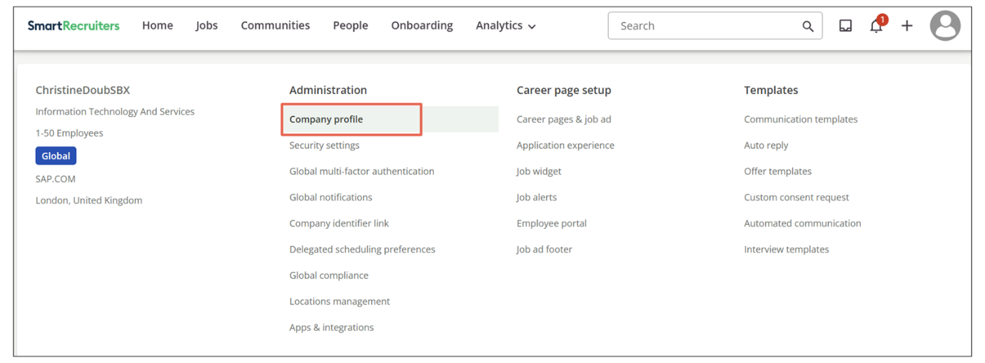
Company Profile Fields
The Company Profile section contains all the default information about your company. This includes details like your company size, address, and logos.
Company Name and Industry
Your company name is displayed at the top of the page. ​​If you need to change it (for example, because of a merge or acquisition) you'll need to submit a support ticket to SmartRecruiters.
- If your company changes its name, there are a few required steps. Republish all existing job postings so the job ad URLs include the new company name.
- Update your job widgets by grabbing the latest widget code and reinstalling it.
You may also need to update the following:
- Screening questions Domain-based authentication settings (if your company domain changed)
- User email addresses in User Management
- SSO configuration on your Identity Provider, especially the Company ID
Caution
Candidates might be unable to complete assessments that were in progress during the name change. To avoid issues, wait until all pending assessments are finished before making the change.
- The Industry field allows you to select the industry that best describes your organization from a predefined list. This is typically set during implementation, but you can change it as needed.
Company Size and Website
Select your company size from the dropdown list provided. Enter your company's website address in the website field.
Company Address
The final fields on this page are for entering your company's physical address. Ensure this information is accurate for proper communication and legal compliance.
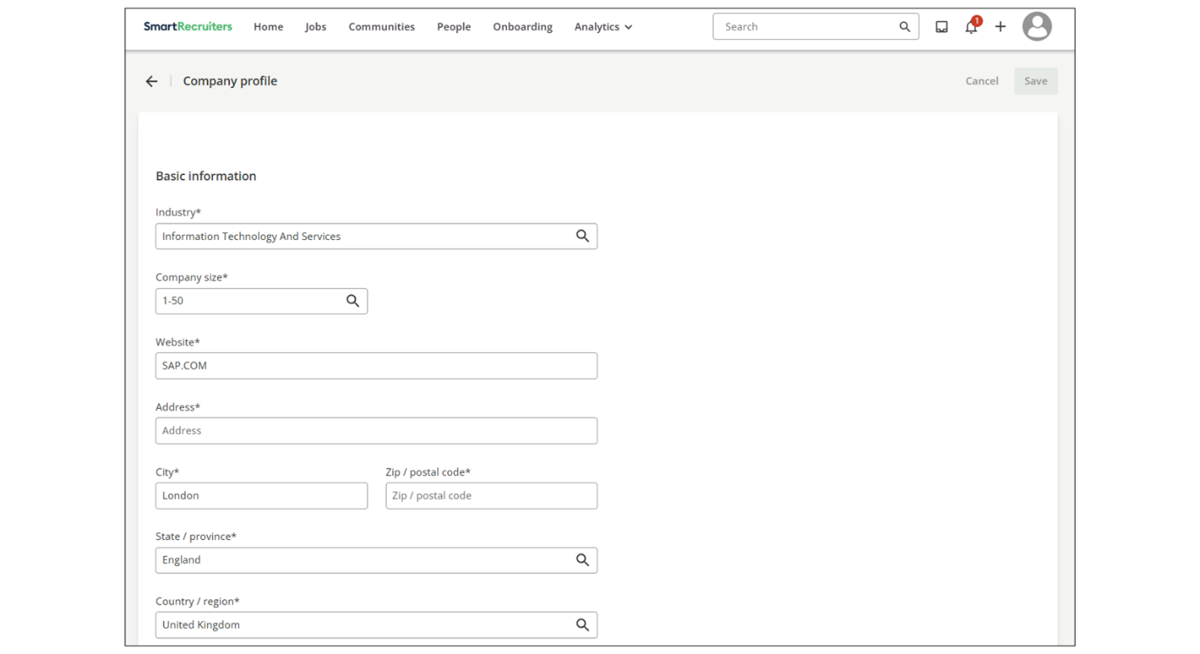
Company Logo
The company logo section allows you to upload both a rectangular and a square logo.
Rectangular Logo
​​​​​The rectangular logo is used in areas like your job ads, applications, and the applicant tracking portal. The recommendation is to use an image at least 188 pixels wide by 100 pixels tall and under 5 MB in size.
Square Logo
The square logo is better suited for social media posts, such as when a job is shared on LinkedIn. While the logos can be the same, using different versions optimized for each platform is recommended. ​​Logos must be at least 80 pixels tall (recommended is 300 x300 px) under 5 MB in size, and in JPEG or PNG format.
Managing Multiple Brands
If your organization has multiple brands within SmartRecruiters, you can add additional logos on the Brand page.
Other Company Options
Below the company logos, you can view the languages purchased for your system. You can also choose to hide the Community and Feedback options from the user menu.
Account Domain Information
​​​The last section displays the account domain for your SmartRecruiters instance and your work email. This information is important for technical support and system administration.
Verify your company domain in SmartRecruiters to automatically add new users when they sign up with an email from that domain.
Note
If your company uses Single Sign-On (SSO), do not enable domain authentication. Otherwise, users might bypass SSO and create password-based accounts instead of being provisioned through SSO.
Security Settings
The Security Settings page allows you to configure automatic logout options for users.
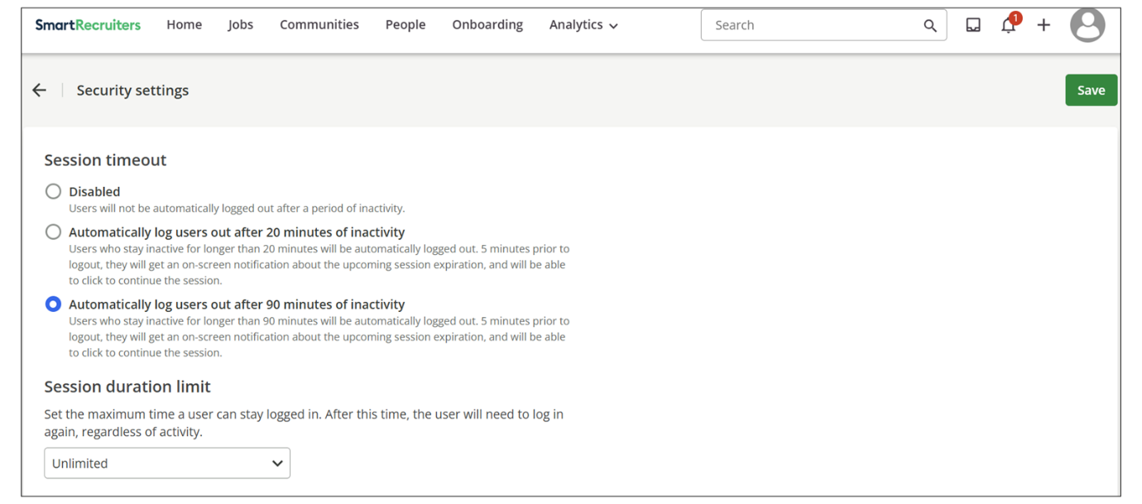
There are three options for automatic logout:
- Disable Automatic Logout: Users will remain signed in even when inactive.
- Logout After 20 Minutes of Inactivity: Users will be logged out after 20 minutes of inactivity.
- Logout After 90 Minutes of Inactivity: Users will be logged out after 90 minutes of inactivity.
If either the 20-minute or 90-minute option is selected, users will receive a pop-up warning five minutes before they are logged out. They can choose to stay logged in by clicking the Keep Me Logged In button. Choosing the appropriate setting balances user convenience with security needs.
Watch this video for more details about Company Profile and Security Settings.
This video is for demonstration purposes. Any references made in this video to previous or later videos in this course (including titles, numbers, links, or sequence) may differ from the current course structure. Additionally, some functionalities shown may have evolved over time due to ongoing enhancements or business decisions.
Summary
- The Company Profile in SmartRecruiters allows you to maintain consistent branding by updating company information and logos.
- Uploading both rectangular and square logos ensures optimal display across various platforms, including job ads and social media.
- Security Settings provide options to automatically log out inactive users, enhancing data security and compliance.
In this video, we're going
to review the company profile and security
settings in SmartRecruiters. To view your company profile,
click your user icon on the top right of the page and
select the Settings option. Once you're on the Settings
page, click Company profile, located in the Global
settings under Administration. The company profile contains
all of your default company information, including your
company size, address, and logos. Your company name is listed at
the top of the page, and if at any time you need to change it, you'll
need to submit a support ticket. The industry field contains a list
of industries for you to choose from that best describes your
organization. This field is usually set during implementation,
but you do have the ability to change it by selecting another
industry from the predefined list. Next, you can select your
company's size from the dropdown list, and then after
that, enter your company's website in the website field.
The last fields on this page are where you can enter your
company's physical address. In the company logo section, you'll
upload a rectangular logo and a square logo. The rectangular logo
is used in places like your job ad, application, and the applicant tracking
portal. The square logo is better suited for social posts, such as
when a job is shared to LinkedIn. In my instance, those
logos are the same, but that may not be the case
for your organization. Any logo must be at least
80 pixels tall and under 5 megabytes in size, as well as
be in a JPEG or PNG format. If you have multiple brands
within SmartRecruiters, you can add additional logos on the
Brands page, which is covered in the Configuring Brands and
Logos video in the university. Below the company logos is where
you can view what languages you have purchased for your system
and decide whether you would like to hide the community and feedback
options from the user menu. The last section on your
company profile is the account domain information, which will
show you the account domain for your SmartRecruiters
instance and your work email. The next area we're going to look at
is the Security settings, which is also located under the Administration
section of the Global settings. On the Security settings page, there
are three options regarding how long a user should be inactive in the
system before they are automatically logged out. The first option you can
select is to disable the automatic logout so that users will stay
signed in even if they're inactive. If you select the second option,
users will be logged out of SmartRecruiters after 20 minutes of
inactivity. And finally, the third option would log users out after 90 minutes
of inactivity. If either the 20 minute or 90 minute option is selected,
users will receive a pop-up warning five minutes before they're logged
out. And from that warning, they can choose to stay logged in by
clicking the Keep Me Logged In button.

Configuring Default Company Email Notifications
Objective
After completing this lesson, you will be able to configure default email notification settings for different hiring team roles in SmartRecruiters.
Company Email Notifications Settings
Managing email notifications effectively is crucial for maintaining smooth communication and collaboration within your recruiting team. As an administrator, setting up default company email notifications in SmartRecruiters ensures that all users receive relevant updates, streamlining workflows and improving overall efficiency.
In SmartRecruiters, administrators can configure default email notifications for various events, ensuring that the right people are informed at the right time. These settings impact how your team collaborates and stays updated on candidate progress.
These notifications can be managed in the Settings page, under Administration, in the Global notifications page.
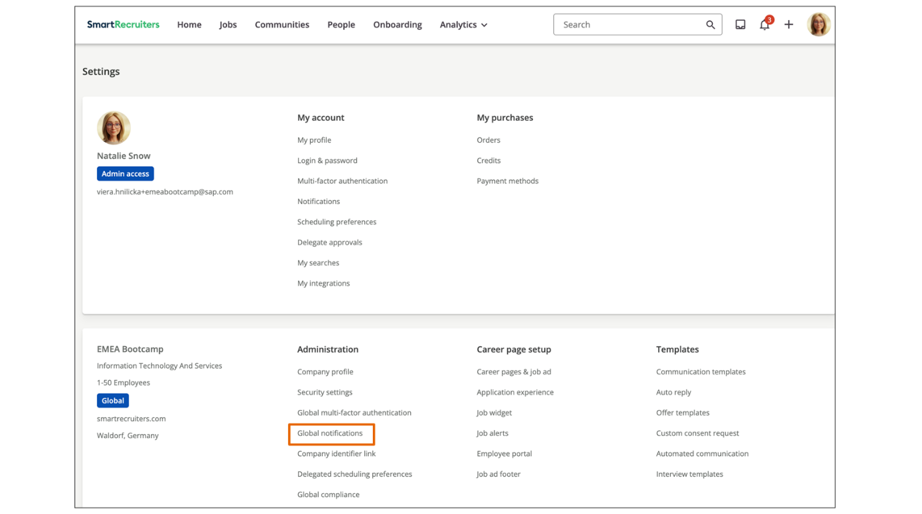
It's important to note that while administrators can set default notifications, individual users retain the ability to customize their own preferences. This means that users can override the defaults to suit their specific needs. The settings configured here serve as a baseline, ensuring that essential notifications are enabled for everyone, unless they choose otherwise.
Email Notifications Categories
There are several categories of notifications you can configure:
- Interviews: This category includes notifications about invitations, reminders, and updates related to interviews and event sessions.
- Candidates: Here, you can select to notify the hiring team when a new candidate applies, when a candidate receives a rating of three or more stars, for upcoming interviews, when a candidate withdraws or defers their application, or when a candidate is ready to re-engage. These notifications ensure that the team stays informed about candidate activity and can respond promptly.
- Offers and hires: These preferences apply to the five standard hiring team roles within SmartRecruiters. You can set notifications for when new hiring team members are added to a job, when candidates enter the offer stage, and when a new hire is made.
- Assessments: This category allows you to send notifications for assessment results and assessment updates. Keeping your team informed about assessment outcomes helps in making timely decisions about candidates.
- Collaboration: Unlike the other categories, this section allows you to choose if all users should receive notifications based on specific events. These events include when a colleague sends a message to a candidate the user has interacted with, when the user is added to a hiring team, when someone comments on the user's posts, or when someone comments on a post the user is mentioned in. These settings promote team collaboration and ensure that everyone stays in the loop.
- Digest: You can enable a weekly digest that summarizes new candidates, their current stage, and any new comments on their applications. Simply click the checkbox under the appropriate role to enable the desired notification. Note that some checkboxes may be grayed out for certain roles due to permission conflicts. It is recommended to keep all boxes checked for more satisfactory hiring team collaboration.
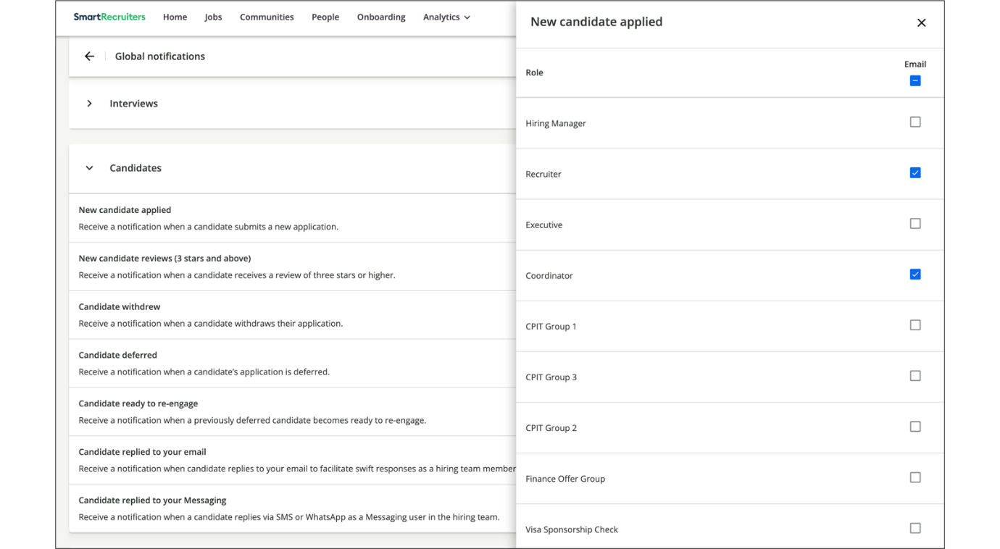
After setting the default notification preferences, you may encounter users who are not receiving certain notifications or are receiving too many. In such cases, guide them to review their own email preferences to ensure they are receiving the notifications they need.
Notification Channels
For each notification event, you may see up to three columns:
- Slack
- Teams
- Email
A checked box means that notifications for that event are enabled for that channel.
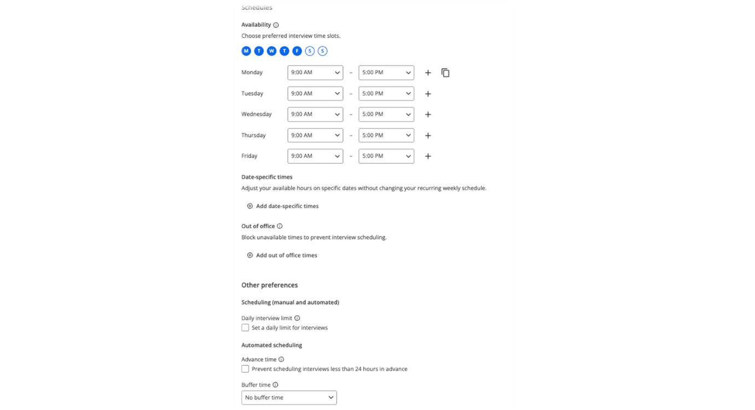
Channel Availability
Channel availability depends on how you configure integrations and global defaults.
- If an admin has not enabled Slack or Teams for your company, these columns will not appear on the Personal notifications page.
- Admins will still see Slack and Teams in Global notifications, with options to connect the integration. Notifications that cannot be used yet are shown as disabled or grayed out.
- Some events are available only by email at the moment. For these events, Slack and Teams columns will not be available, even if the integrations are connected.
Slack and Teams Defaults for Admin Users
In Global notifications, admins can:
- Turn on Slack and Teams notifications at the company level so that, by default, all eligible users receive those notifications when they connect Slack or Teams.
- Use the header of each channel column (Slack, Teams, Email) or each category to select all events at once, then fine-tune individual rows.
Note
This helps ensure that users who connect Slack or Teams start with a sensible set of notifications already enabled, instead of having to configure everything from scratch.
Configure Global Notifications
Global notifications can be used to define how notifications work across your company.
Global settings control:
- Which events are available at all.
- Which channels (Slack, Teams, Email) are available for each event.
- Which notifications are turned on by default for new users or newly connected channels.
To manage Global settings:
Steps
- Go to Settings→Administration→Global notifications.
- Use the Search bar to find a specific event.
- Expand a category, such as Interviews, Candidates, or Offers and hires.
- Configure channels:
  - Use the header of a column (Slack, Teams, Email) to select all events in that category.
  - Adjust individual rows as needed by selecting or clearing the relevant checkboxes.
- If your company uses custom hiring team roles, open the role configuration for events that support them and choose which roles should receive that notification. (For example, custom coordinator or regional recruiter roles.)
- Select Save changes.
Note
You can use Global settings to keep the configuration simple (for example, send most interview notifications to everyone over Slack and Teams), then let users fine-tune what they receive on their Personal notifications page.
Global vs. Personal Notification Settings
Global and personal notification settings work together in the following way:
- Global notifications define:
  - Which events exist.
  - Which channels are available for each event.
  - The default state (on/off) for each event and channel.
- Personal notifications allow each user:
  - Adjust their own preferences where personal edits are allowed.
  - See only the events and channels that the admin has enabled globally.
If an event is turned off globally for a channel, users cannot enable it for themselves. If a channel is not integrated (for example, Slack is not connected), that column will not appear on user pages.
Custom Hiring Team Roles and Eligibility
SmartRecruiters supports configuring notifications that are sent to both default and custom hiring team roles.
To do this, in either Global notifications or Notifications, in the row of the notification you want to configure, click Define per hiring team role and select each role as necessary.
Because custom roles and access configurations can vary widely from one customer to another, the system only checks whether a notification can be sent when the event actually occurs. It cannot always predict in advance whether a specific user and role combination will be eligible for a given notification.
If someone expects a notification but does not receive it, admins should perform the following actions to troubleshoot:
- Confirm the user is on the hiring team for the relevant job, with the correct role.
- Check Global notifications to verify that the event and channel are enabled and that the relevant default and custom roles are selected.
- Confirm that the user has connected Slack or Teams (if they are expecting notifications on those channels).
Note
This behavior is expected given the flexibility of custom hiring team roles and is not a defect.
Watch the video below for more information on configuring company email settings.
This video is for demonstration purposes. Any references made in this video to previous or later videos in this course (including titles, numbers, links, or sequence) may differ from the current course structure. Additionally, some functionalities shown may have evolved over time due to ongoing enhancements or business decisions.
Summary
- Administrators can configure default email notifications for hiring team roles.
- Notifications are categorized into Interviews, Candidates, Offers and hires, Assessments, Collaboration and Digest.
- Users can override default settings to customize their notification preferences.
- Admins set events, channels, and defaults; users edit only within global settings.
- Channel columns depend on Slack/Teams integration; some events email-only; critical emails can’t be disabled.
In this video, we're going to
review how to configure the default company email
notifications in SmartRecruiters. To go to the Settings page, click
on your User icon on the top right of the page and select the Settings
option from the dropdown menu. Once you're on the Settings page,
under the Administration section, click the All company
email settings option. What we're going to look at today
is how an admin can set the default for all users for specific
notifications. But it's important to remember that no matter what defaults are set, individual users have the ability to change them. We go
over this in our login and user settings video where we show how
users can override these defaults and select their own notification
preferences. These notification settings are usually set up during
implementation but admins have the ability to change these as needed.
There are four main categories of notifications with the first being
Offers, hires and digests. You'll see that these preferences
are only applicable to our five standard hiring team roles, so keep
in mind that if you have custom hiring team roles, you won't be
able to set notifications for them. Under the Offers category, you have
the option to send a notification when new hiring team members are
added to a job, when there are new candidates in the offer stage, or
when a new hire is made. You can also send a weekly digest that will provide
a summary of the new candidates on a job, the current candidates
and what hiring stage they are in, and any new comments that have been
added to candidates' applications. To set a notification to a hiring
team role, simply click the checkbox under the role that corresponds to
the notification you want them to receive. Some checkboxes are grayed
out under the interviewer role so that certain notifications won't
conflict with interviewer permissions. The next category is Assessments,
and here you can send notifications for assessment
results and assessment updates. Next is the Candidates category
and here you can select to notify the hiring team when a new candidate
has applied or if a candidate receives a rating of three or
more stars. You can also send notifications for any upcoming
interviews if a candidate withdraws or defers their application or if a
candidate is ready to re-engage. The last category is collaboration
and unlike the other categories here you will choose if all users should
receive notifications based on specific events in the system. These
events include if a colleague sends a message to a candidate that the
user has had a conversation with, if the user was added to a hiring team,
if someone comments on the user's posts, or if someone comments on a
post that the user is mentioned in. When you're ready, click the Save Changes button at the
bottom of the page. You'll receive a prompt before
saving that asks if you would like to apply these changes only
to users who have not set their own preferences, or if you want
to save these changes for all users, which would override
their previously set preferences. Note that if you do choose to
save the changes for everyone, users can still go back
into their preferences and change them back to what they want. Click the Save Changes button again to save the notification preferences. Now that you've set the
notification preferences, if a user feels that they're not
receiving certain notifications or they're receiving too many, you can
help them review their own email preferences to make sure they're
getting the notifications they need.
Integrating SmartRecruiters with Apps and Configuring WebSSO
Objective
After completing this lesson, you will be able to explain how to integrate SmartRecruiters with apps and configure WebSSO.
The Apps & Integrations Page
The Apps & Integrations page within Administrator Settings serves as the catalog and status center for all prebuilt, productized integrations that can connect with SmartRecruiters. This interface provides an immediate view of the external technologies linked to the platform, such as calendar or tag management services.
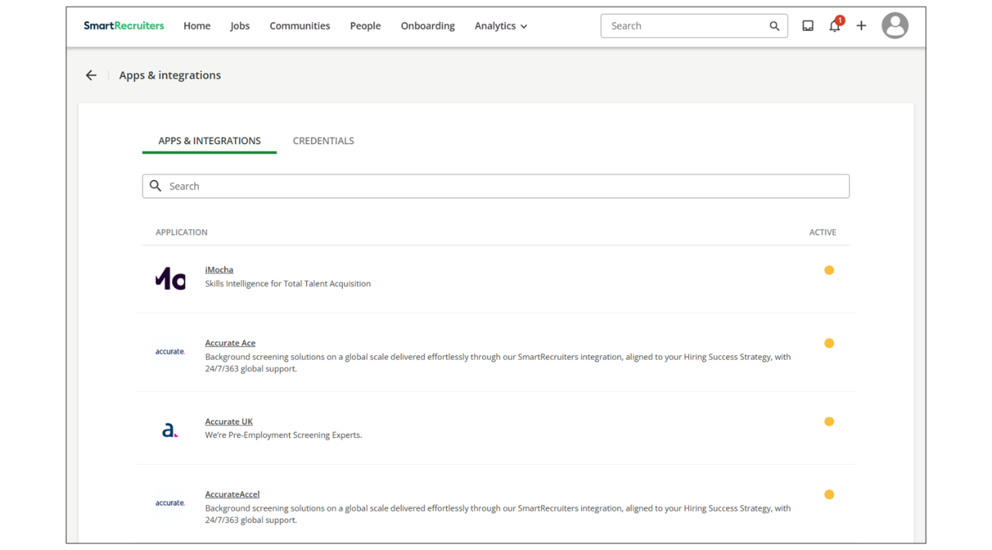
Key information available here includes:
- Integration Status: A color-coded icon, typically green for active and connected and yellow for inactive, instantly indicates the operational status of each integration.
- Search and Discovery: A search bar facilitates the quick location of a specific integration.
- Setup Requirements: While the page lists available options, users should note that successful activation often requires an existing account with the third-party provider and potential assistance from an internal IT or technical team due to varying setup complexities. ​​Further detailed setup guidance for each integration is available via the Help Center.
API Credentials Management
The Credentials tab is the dedicated workspace for organizations wishing to build custom integrations using the SmartRecruiters Application Programming Interface (API). This tab provides the tools necessary to generate secure authentication methods.
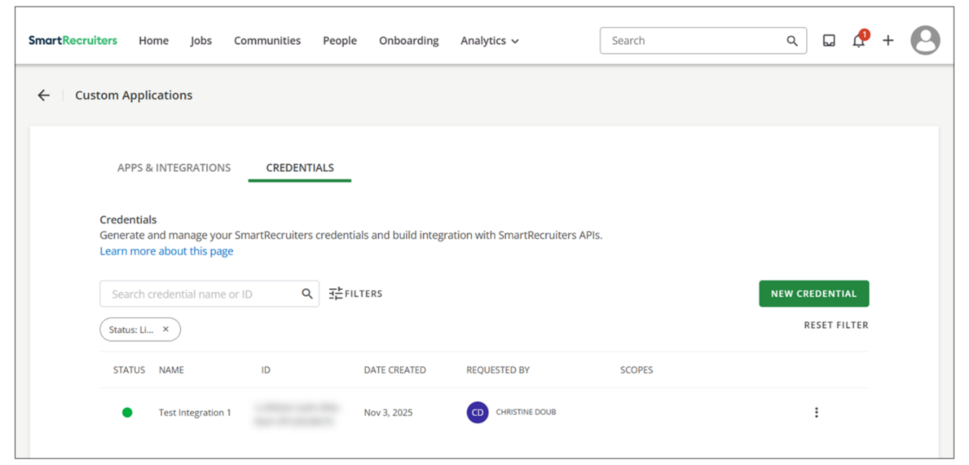
When creating a new credential, the system requires and captures several key data points:
- Credential Type: Users must select the method of authentication, typically choosing between an OAuth client ID (recommended for production instances as it allows for defined access scopes) or an API Key (best used for testing and rapid integration proof-of-concept, as it grants full access to public API endpoints).
- Identification Data: The credential requires a name and a brief description for internal identification and management. An optional user avatar can also be created.
- Access Scopes and Governance: To restrict the data the integration can access, administrators can assign a System Role and an Access Group to the credential. This governance ensures that the credential's permissions are limited (for example, restricted only to jobs within a specific geographic region, such as the South America access group), maintaining security boundaries.
- Security Key Generation: Upon generation, a unique API key is displayed once for security purposes, requiring the user to immediately copy and securely store the key.
The Credentials tab also offers search and filtering options, allowing administrators to refine the credential list based on the type of authentication, scope, creation date, and current status. Credentials can be easily reviewed, edited (name, role, group, description), or revoked to instantly terminate an integration's access for security management.
Creating a New Credential
To create a new credential, you have two options for types of credentials you ​can​​ create:
- OAuth Client ID: Recommended for building applications on top of SmartRecruiters in a production environment. Allows administrators to define access scopes.
- API Key: Provides full access to SmartRecruiters' public API endpoints and is best used for testing integrations.
Once your credential is created, you can then edit the credential's name, system role, access group, or description. You can also revoke a credential when it is no longer required.
WebSSO Configuration
The WebSSO (Single Sign-On) configuration page manages the platform's authentication method. SSO allows users to log in to SmartRecruiters using a single set of credentials managed by an external identity provider.
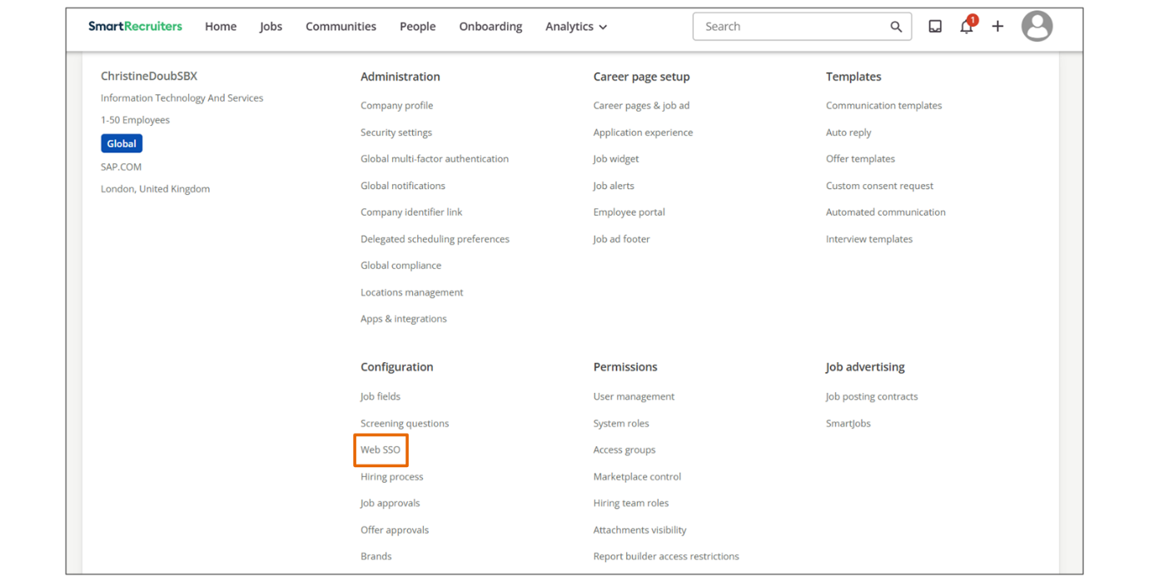
The sole function of this page is to enable or disable SSO via a toggle switch, requiring collaboration with the organization's IT team to correctly configure the connection with the identity provider. This feature centralizes user management and enhances organizational security.
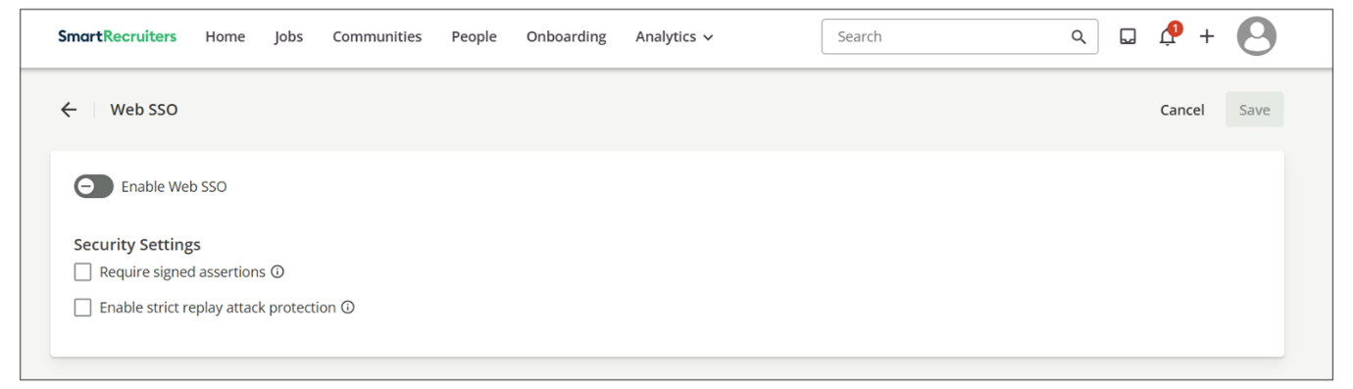
Watch the video below for more information!
This video is for demonstration purposes. Any references made in this video to previous or later videos in this course (including titles, numbers, links, or sequence) may differ from the current course structure. Additionally, some functionalities shown may have evolved over time due to ongoing enhancements or business decisions.
Summary
- The Apps & Integrations page provides a centralized location to manage connections with other applications, allowing for streamlined workflows and improved data flow with SmartRecruiters.
- The Credentials tab allows users to generate API keys and OAuth client IDs to build custom integrations with SmartRecruiters, offering flexibility in connecting with other systems.
- Configuring Web SSO simplifies the login process for users by enabling them to access SmartRecruiters with a single set of credentials, enhancing security and user experience.
In this video, we're going
to review the Apps and Integrations and Web SSO
pages in Smart Recruiters. You can access the Apps and Integrations page by going to the Apps and
Integrations option under the Administration section
in the Global settings. On the Apps and Integrations page,
you'll see all of the productized integrations that are available
to connect to SmartRecruiters. The active status icon will
appear next to each integration and a yellow icon indicates that
the integration is inactive, while a green icon indicates the integration
is active and connected. At the top of the page, you can search
for a particular integration, such as our calendar integration, or
the Google Tag Manager integration. Every integration will have
different setup requirements, such as having an existing account for
that provider or needing assistance from your IT or technical team.
Please refer to the Help Center for more specific information
relating to each integration. On the Credentials tab you can request
credentials to build your own integrations with the SmartRecruiters
API. To learn more about our API you can click on the Learn more
link and go to our developer site. The developer site provides
detailed guides on the types of authentication and APIs and on the
API Reference page you can view what SmartRecruiters endpoints are
available and test API. Back on the Credentials page you
can use the search bar to find specific credentials, and the filters
allow you to refine your search by filtering by the type of
authentication, the scope, the date when the credential was
created, and the credential status. To create a new credential, click the New Credential on the right side of the page. You'll first need to choose what type
of credential you want to create. An OAuth client ID is a standard
way to build applications on top of SmartRecruiters and allows
your admins to define scopes around access this type is recommended for
any credentials being created in your production instance of SmartRecruiters. An API key will give a user full access to SmartRecruiters
public API endpoints and is best used for testing integrations. For this
example we'll create an API key and when you click the Next button
you'll be brought to the page where you can set up your key. You have the
option to create a user avatar for your credential and then you'll
need to give your credential a name. You also have the ability to
further define the credential access by assigning a system
role and access group. For example, if I assign this
credential the standard system role and the South America access
group, this will ensure that the resources accessed by this
credential are restricted to South America jobs, along with
the standard role permissions. Lastly, you need to add a brief
credential description, and when you're ready, click the Generate button.
At the bottom of the page a pop-up will display with your generated API
key along with the option to copy this key to your clipboard. This pop
up will only display once so it's important to copy your key and
store it in a secure place. Click the Done button once you've copied your
key and now your credential has been created. To view your credential
details or to edit your credential information click on the ellipses
to the right of your key on the credentials list and select the details
option this will bring you to your credential information where you
can click the edit button on the top right of the page and change your
credentials name, system role, access group, or description. You also can
revoke a credential by clicking the revoke button at the top of
the page or by selecting the revoke option from the ellipses next to the
credential. On the credentials list the other area we're going to review
is the Web SSO Configuration page To get to the Web SSO page,
click on the Web SSO option under the Configuration
section of the Global Settings. As mentioned in other videos,
SSO or Single Sign-On is an authentication method that allows
users to log in with a single ID to multiple related yet independent
software systems. To enable SSO, click the toggle on the Web
SSO page, and you'll need to work with your IT team or whoever oversees
your single sign-on provider, referenced here as an identity
provider, to configure SSO. Thank you.

Managing Marketplace Access and Visibility
Objective
After completing this lesson, you will be able to configure Marketplace access and visibility settings for different user roles to control purchasing power and user experience.
Marketplace Access for Users
As an administrator, you need to control which users in your organization have access to the Marketplace and how they interact with it. This includes managing access to purchase assessments, postings to job boards, and sending jobs to agencies.
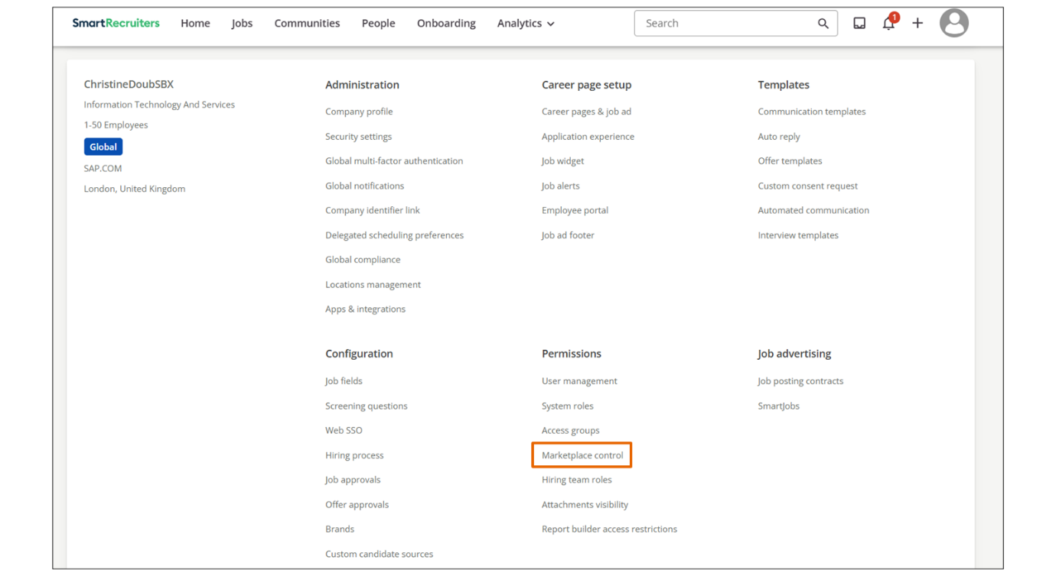
Additionally, you need to manage the visibility of the Marketplace link in the navigation menu and the display of assessments on candidate profiles to streamline the user experience.
When managing Marketplace access, the following accessibility options are available:
- Standard User Access to Marketplace: This setting determines whether standard users have access to the Marketplace. When enabled, standard users can purchase assessments, post to job boards, and send jobs to agencies. When disabled, standard users will not have access to these features. This setting provides a straightforward way to control purchasing power within your organization.
- Display Marketplace on Navigation Menu: This setting controls the visibility of the Marketplace link in the navigation menu. If this setting is turned off, the Marketplace option will not appear in the navigation menu for users. If it is turned on, the Marketplace option will be visible. This setting affects admins, extended users, standard users, and custom users who have the Create a Job setting enabled. This allows you to streamline the user interface and reduce clutter for users who do not need access to the Marketplace.
- Display Assessments on Candidate Profile: This setting controls whether the assessment section appears on the candidate profile. When turned on, users will see the option to browse and purchase different assessments directly from the candidate profile. When turned off, the assessment section will not be visible on the candidate profile. This setting allows you to customize the candidate profile view and focus users on the most relevant information.
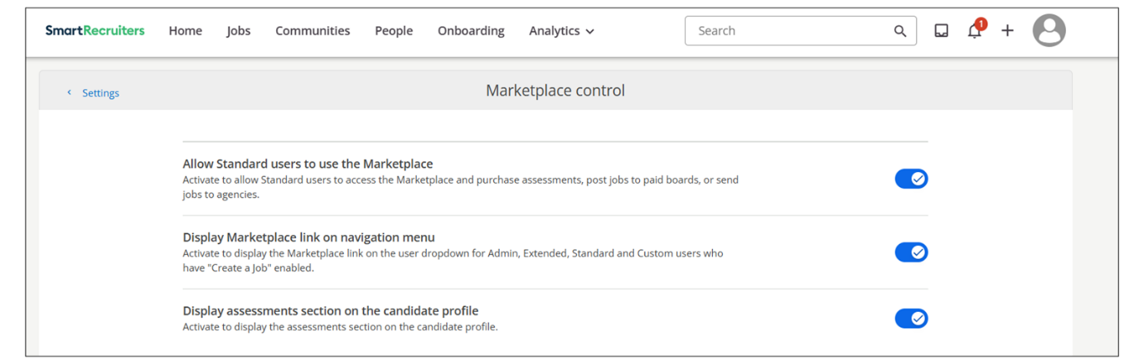
By configuring these settings, administrators can effectively manage Marketplace access and visibility for different user roles, ensuring that users have the appropriate level of access and a streamlined user experience.
Configure Marketplace Access
Managing Marketplace access can be controlled using the Company Settings page.
Steps
- Navigate to the Settings page, using the main Account icon.
- Within the Permissions section, select Marketplace Control.
- Select the accessibility option(s) necessary for your users.
Watch the video below for more information about configuring Marketplace Control.
This video is for demonstration purposes. Any references made in this video to previous or later videos in this course (including titles, numbers, links, or sequence) may differ from the current course structure. Additionally, some functionalities shown may have evolved over time due to ongoing enhancements or business decisions.
Summary
- Standard users can be granted or denied access to the Marketplace, controlling their ability to purchase assessments and interact with job boards.
- The visibility of the Marketplace link in the navigation menu can be toggled on or off for various user roles, streamlining the user interface.
- The display of assessments on candidate profiles can be controlled, allowing administrators to customize the user experience.
Hi, in this video, we're
going to review the additional settings available
for Marketplace Control as part of your user
rules and permissions. Admins can go in and toggle
on the various settings by accessing the Settings
Admin page, scroll down to Permissions, and click
on Marketplace Control. The settings that we see is allowing
standard users access to the Marketplace, the option to display
the Marketplace on the navigation menu, and the option to display
assessments on the candidate profile. The first one is fairly
straightforward. Standard users can either have access to Marketplace
or no access to Marketplace, which will limit if they're
able to purchase assessments or post to different job boards
or send jobs to agencies. The next setting gives you
options to display the Marketplace link on the navigation menu. If
I have this turned off, I will not see the Marketplace option
on the navigation menu. If I toggle this back on, then the
Marketplace option will appear. As this setting states, this limits
visibility for admins, extended, standard, and custom users who have
the create a job setting enabled. The last option on this
page is the option for the assessment section to appear
on the candidate profile. If it's turned on, you will
see the option here on the profile to browse and purchase
different assessments. If I turn this off and
refer back to the candidate profile, the assessment
section is now gone. Thank you. Thank you.

